https://stackoverflow.com/questions/338436/how-can-i-view-an-old-version-of-a-file-with-git

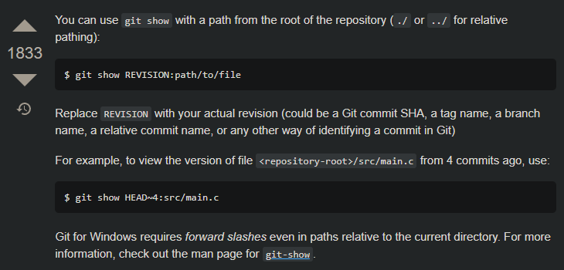

Example

git show HEAD~8:backend/knexfile.js